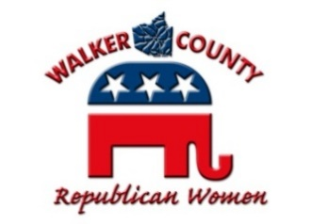
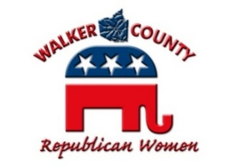
WALKER COUNTY REPUBLICAN WOMEN

P.O. Box 7382, Huntsville, Texas 77342
936-661-3815
walkercountyrepublicanwomen@gmail.com
www.wcrwtx.org

Lunch Order Form

Meal Reservation dEADLINE: lunch form & payment must be received
by 5:00pm ThurSDAY PRIOR TO MEETING dATE, no exceptions

Luncheon Cost: $12.00 (Delivered by Humphrey’s)
- Chicken Caesar Salad
- Chicken Pasta Salad
- Deli Club Sandwich (turkey, ham, bacon, lettuce, tomato, mayo) with Fries
- BLT: Bacon/Lettuce/Tomato Club Sandwich with Fries
- Chicken Tenders with Fries
- Alfredo Chicken Pasta
*Water Provided *Meal Purchase Assist with Venue Rental

Payment: EMAIL ALL COMPLETED FORMS to WCRW.Hospitality@gmail.com with the following information:
- If Check:
  - Mail a Printed Order Form with a Check to WCRW PO Box 7382, Huntsville, TX 77342
  - Please send an email to Hospitality of your order detail for confirmation that it is in the mail, and to ensure that your meal is ordered.
- If Credit Card or Bank Draft use VENMO APP: @WCRWLadies
  - Email Order Form and VENMO Confirmation to Hospitality email (contact us for assistance if needed)
  - Select Personal and Please DO NOT select Instant as it charges the club a FEE
  - We no longer accept credit card information for your personal security
- IF Cash:
  - Email Form and Coordinate Cash Payment with Hospitality Chair

Name: ______________________________________________________________________________________________________
Requestor Confirmation Email Address: __________________________________________________________________________
Phone Number: ___________________________ If Not a member, Occupation & Employer: _______________________________

Payment Type: __________________ VENMO @WCRWLadies ________ CHECK (#______________) ________ CASH

Meal Choices Below (Indicate How Many Per Item):
Salads: __________ Chicken Caesar __________ Chicken Pasta Salad
Sandwiches: __________ Deli Club __________ BLT Club
Tenders: __________ Chicken Tenders with Fries
Pasta: __________ Alfredo Chicken Pasta

Total $ Amount: ___________________________________ 2/8/23 Rev 1

Political advertising paid for by Walker County Republican Women (Susan Miller, PAC Treasurer, PO Box 7382, Huntsville, Texas 77342). Contributions are not federal tax deductible as charitable contributions. Corporate Contributions Are Not Permitted. Revised 01/04/23

